**ICS 365 - Concepts of Programming Languages.**

**Problem Set 1**

**Due: 06/06/2017 Points: 30**

1.Derive and draw parse trees for the given expressions using the following grammar. 15 points

<E> -> <E> + <T>

| <E> – <T>

| <T>

<T> -> <T> * <F>

| <T> / <F>

| <F>

<F> -> <N> | ( <E> )

<N> -> 0 | 1 | 2| 3 | 4 | 5 | 6 | 7| 8 | 9

a) 4 + 5 * 7 b) 4 + (5 * 7)

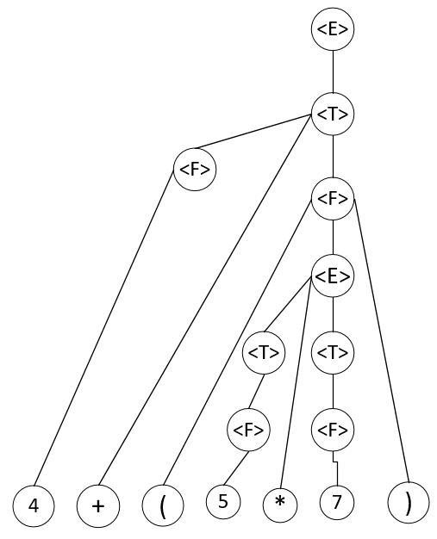

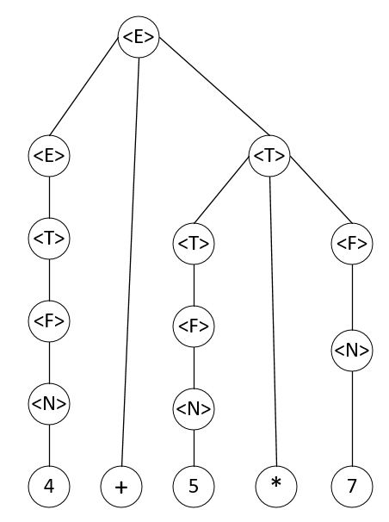

a) b)

2. Prove that the following grammar is ambiguous. 3 points

<S> -> <E>

<E> -> <E> + <E> | <N>

<N> -> 1 | 2 | 3

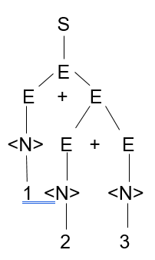 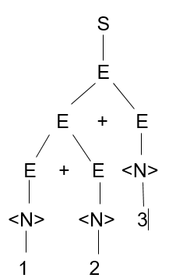Two distinct parse trees = ambiguity

3.Compute the weakest precondition for each of the following assignments

statements and postconditions 12points

|  |  |
| --- | --- |
| 1. a =2*(b-1)-1 | {a>0} |
| 2. b =(c+10)/3 | {b>6} |
| 3. a = a+2 * b - 1 | {a > 1} |
| 4. x = 2 * y + x-1 | {x > 11} |
|  |  |

1. a = 2 * (b – 1) – 1 {a > 0}

2 * (b – 1) – 1 > 0

2 * b – 2 – 1 > 0

2 * b > 3

b > 3 / 2

1. b = (c + 10) / 3 {b > 6}

(c + 10) / 3 > 6

c + 10 > 18

c > 8

1. a = a + 2 * b – 1 {a > 1}

a + 2 * b – 1 > 1

2 * b > 2 – a

b > 1 – a / 2

1. x = 2 * y + x – 1 {x > 11}

2 * y + x – 1 > 11

2 * y + x > 12